**PRACTICAL ASSIGNMENT**

**WEB TECHNOLOGIES**

NAME –HARSH SAINI

CLASS- B.C.A(AI/ML)

ROLL NO- 24/SCA/BCA(AI&ML)/025

GROUP-G1

QUESTION 1 **CREATE A SIMPLE HTML PAGE USING BASIC TAGS?**

<HTML>

<HEAD> INTRODUCTION

<TITLE >MRIIRS</TITLE>

</HEAD>

<BODY>

<H1>HELLO WORLD</H1>

</BODY>

</HTML>

**HELLO WORLD**

Q2= **Create a web page that displays your name to the screen?**

**Ans=**

<HTML>

<HEAD>

<TITLE> HELLO WORLD </TITLE>

</HEAD>

<body>

<H1> HARSH SAINI </h1>

</body>

</html>

# HARSH SAINI = OUTPUT

**Q3= Create a web page and show the output from 1 to 10 in separate lines?**

<HTML>

<HEAD>

<TITLE> HELLO WORLD </TITLE>

</HEAD>

<body>

1<br> 2<br> 3<br> 4<br> 5<br> 6<br> 7<br> 8<br> 9<br> 10<br>

</body>

</html>

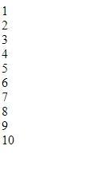 **=OUTPUT**

**Q4= Create a webpage and show the output from 1 to 10 in separate lines, each number being in different color?**

<HTML>

<HEAD>

<TITLE> HELLO WORLD </TITLE>

</HEAD>

<body>

<font color="red"> 1 </font><br>

<font color="blue"> 2 </font><br>

<font color="green"> 3 </font><br>

<font color="black"> 4 </font><br>

<font color="brown"> 5 </font><br>

<font color="pink"> 6 </font><br>

<font color="orange"> 7 </font><br>

<font color="purple"> 8 </font><br>

<font color="grey"> 9 </font><br>

<font color="yellow"> 10 </font><br>

</body>

</html>

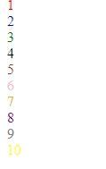  **=OUTPUT**

**Q5= how to make a picture as a background on my web pages?**

ANS= <HTML>

<HEAD>

<TITLE> HELLO WORLD </TITLE>

</HEAD>

<body>

<body background="C:\Users\student\Downloads/download.jpg">

</body>

</html>



**= OUTPUT**

**Q6=Create a web page to print a paragraph with 4-5 sentences, each sentences shall have a different font?**

**Ans=** <html>

<head>

<title> BCA IB </title>

</head>

<body>

<h1>HARSH SAINI</h1>

<P>

<B>My name is harsh saini.</B><br>

<I>I am Currently studing in manav rachna international institute of research and science. It is situated in

Badkhal, Faridabad. </I>

<br> <U> My course that i am pursuing right now is BCA(AI/ML) </U>.

<br><B> My Hobbies are playing games and watching movies and playing football.</B><br>

</p>

</body>

</html>

# HARSH SAINI

**My name is harsh saini.**  
*I am Currently studing in manav rachna international institute of research and science. It is situated in Badkhal, Faridabad.*  
My course that i am pursuing right now is BCA(AI/ML) .  
**My Hobbies are playing games and watching movies and playing football.**

**= OUTPUT**

**Q7=**write a HTML code to print a paragraph that is description of a book,it shall include the title of the book,title should be underlined?

# STORY OF ANNABELLE

According to the Warrens, a student nurse was given the doll in 1970. They said that the doll behaved strangely, and that a psychic medium told the student that the doll was inhabited by the spirit of a deceased girl named "Annabelle". The student and her roommate tried to accept and nurture the spirit-possessed doll, but the doll reportedly exhibited malicious and frightening behavior. It was at this point that the Warrens say they were first contacted, moving the doll to their museum after pronouncing it demonically possessed. The doll remained in a glass box at The Warrens' Occult Museum in Monroe, Connecticut until the museum's closure over zoning violations.

**Q8- Write a HTML code to print your name using heading tag, every letter shall be of different heading size?**

<html>

<head>

<title>HARSH</title>

</head>

<body>

<h1>H</H1>

<H2>A</H2>

<H3>R</H3>

<H4>S</H4>

<H5>H</H5>

</BODY>

</HTML>

# H

## A

### R

#### S

##### H

**Q9:Write Html code to print the sequence of number 1-20. each no shall be in different line with number 2 next to it as subscript, an equal sign and the result?**

**ANS=**

: <html>

<head>

<title>Number Sequence</title>

</head>

<body>

<p>1<sub>2</sub> = 1</p>

<p>2<sub>2</sub> = 4</p>

<p>3<sub>2</sub> = 9</p> <p>4<sub>2</sub> = 16</p> <p>5<sub>2</sub> = 25</p> <p>6<sub>2</sub> = 36</p> <p>7<sub>2</sub> = 49</p> <p>8<sub>2</sub> = 64</p> <p>9<sub>2</sub> = 81</p>

<p>10<sub>2</sub> = 100</p> <p>11<sub>2</sub> = 121</p> <p>12<sub>2</sub> = 144</p> <p>13<sub>2</sub> = 169</p> <p>14<sub>2</sub> = 196</p> <p>15<sub>2</sub> = 225</p> <p>16<sub>2</sub> = 256</p> <p>17<sub>2</sub> = 289</p> <p>18<sub>2</sub> = 324</p> <p>19<sub>2</sub> = 361</p> <p>20<sub>2</sub> = 400</p> </body>

</html>

**OUTPT=**

**:**

**12 = 1**

**22 = 4**

**32 = 9**

**42 = 16**

**52 = 25**

**62 = 36**

**72 = 49**

**82 = 64**

**92 = 81**

**102 = 100**

**112 = 121**

**122 = 144**

**132 = 169**

**142 = 196**

**152 = 225**

**162 = 256**

**172 = 289**

**182 = 324**

**192 = 361**

**202 = 400**

**Q10-Write HTML code to display an image with border of size with width 200, height 200 pixels, leaving h space and v space of your choice with image hanging in the right side of the screen?**

**ANS=**

**:** <HTML>

<head>

<title>Image Display</title>

<style>

img {

border: 2px solid black;

width: 250px;

height: 250px;

display: block;

margin-left: auto;

margin-right: 0;

margin-top: 20px;

margin-bottom: 20px; }

</style>

</head>

<body>

<img src="C:\Users\student\Downloads/jerry-zhang-nxu_VUcBVdA-unsplash.jpg" alt="Sample Image">

</body>

</html>

**output=**

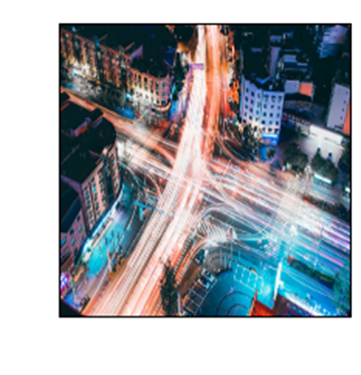

**Q11-** Write a HTML code to ceate a webpage with heading the heading shall be displayed at the top-centre of the page and the image shall be at the centre, just below the heading.

**ANS=**

<html>

<head>

<title> centre image and heading</title>

<style>

body{

margin: 0;

text-align: center;

align-items: center;

</style>

</head>

<body>

<h1>AVENGERS ENDGAME</H1>

<img src="C:\Users\HARSH SAINI\Downloads/avengers endgame.jpg" alt="avengers endgame">

</body>

</html>

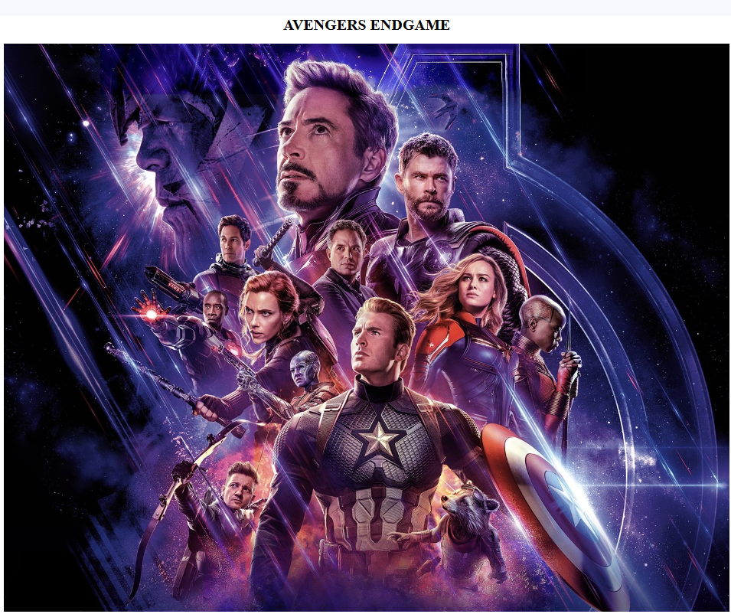

**Q13-** Create a Table using rowspan and colspan taking example of student record.

**ANS=**

<html>

<head>

<title> 1st year class </title>

</head>

<body>

<h1> class data </h1>

<table border="2">

<tr>

<th> name</td>

<th> roll no</td>

<th> class</th>

</tr>

<tr>

<td >Harsh</td>

<td colspan="2">25</td>

</tr>

<tr>

<td> RIAZ</td>

<td> 39</td>

<td> BCA </td>

</tr>

</table>

</body>

</html>

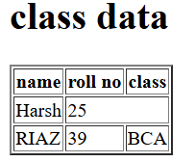

**Q14-** write a html code using table tag <table> and cellpadding and cell spacing as its attributes.

<html>

<head>

<title>Cellpadding and Cellspacing table</title>

</head>

<body>

<h1>Student Record</h1>

<table border="1" cellpadding="10" cellspacing="5">

<tr>

<th>rank</th>

<th>Name</th>

<th>Maths</th>

<th>webtech.</th>

<th>database</th>

</tr>

<tr>

<td>101</td>

<td>HARSH</td>

<td>80</td>

<td>85</td>

<td>78</td>

</tr>

<tr>

<td>102</td>

<td>RIAZ</td>

<td>88</td>

<td>90</td>

<td>82</td>

</tr>

<tr>

<td>103</td>

<td>ABHINAV</td>

<td>98</td>

<td>87</td>

<td>95</td>

</tr>

</table>

</body>

</html>

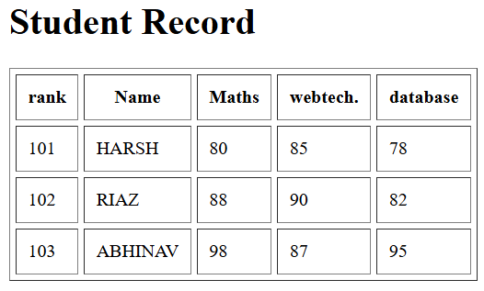

**Q15**- Create unordered, ordered and definition list taking examples of your subjects in MCA 1st 2nd and 3rd semester.

<html>

<head>

<title>MCA Subjects List</title>

</head>

<body>

<h1>MCA first three semester list</h1>

<h2>1st Semester Subjects</h2>

<ul>

<li>Data Structures</li>

<li>Programming in C</li>

<li>Computer fundamentals</li>

<li>Database Management Systems</li>

<li>Mathematics</li>

</ul>

<h2>2nd Semester Subjects</h2>

<ol>

<li>Software Engineering</li>

<li>Mathematics for computer science</li>

<li>Web Technologies</li>

<li>Advanced DBMS</li>

<li>Computer Organization and Architecture</li>

</ol>

<h2>3rd Semester Subjects</h2>

<dl>

<dt>Machine Learning</dt>

<dd>Machine learning is a subset of artificial intelligence that focus on developing algorithms and statistical modeks.</dd>

<dt>Cloud Computing</dt>

<dd>Cloud computing is the delivery of computing services over the internet, allowing users to access to store data and applications remotely rather than on local servers on personal computers.</dd>

<dt>Artificial Intelligence</dt>

<dd>Artificial intelligence refers to simulation of human intelligence in machine programmed to think, learn and problem solve like humans.</dd>

<dt>Big Data Analytics</dt>

<dd>Data analytics involves the systematic computational analysis of data sets to uncover patterns, trends, and insights that can inform decision-making.</dd>

<dt>Mobile Application Development</dt>

<dd>Mobile application development is the process of creating software applications that runs on mobile devices.</dd>

</dl>

</body>

</html>

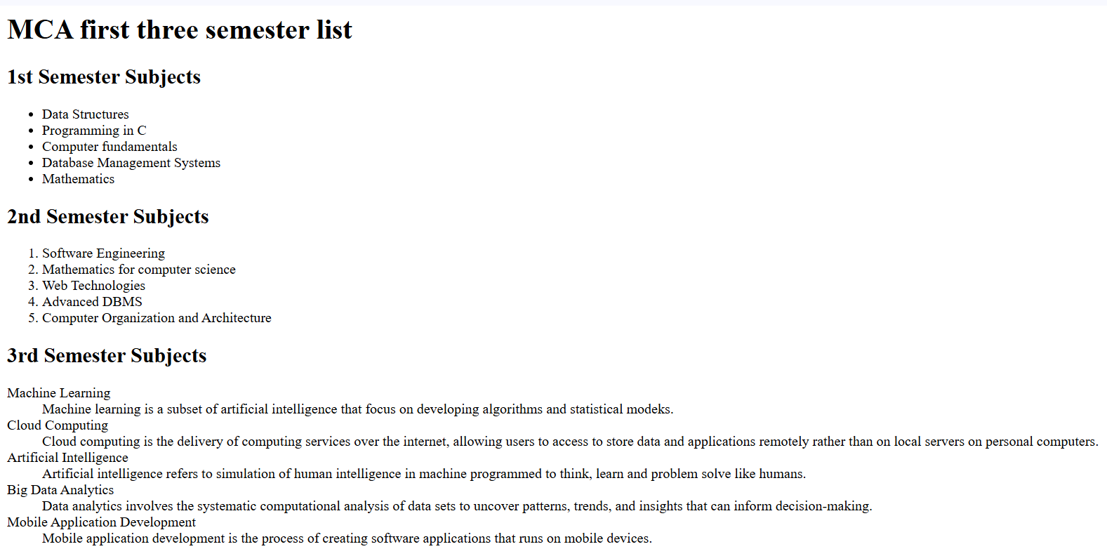

**Q17-** Write a html code to design a form in html using controls and buttons such as teabox, textarea, password, submit button, browse button, drop down menu

**ANS=**

<html>

<head>

<title>registration form basic</title>

</head>

<body>

<h1>basic registration form</h1>

<form>

NAME

<input type="text"/><br>

EMAIL

<input type="email"/>

create password

<input type="password"/><br>

address<br>

<textarea rows="10" cols="50"></textarea><br>

<button>submit</button>

</form>

</body>

</html>

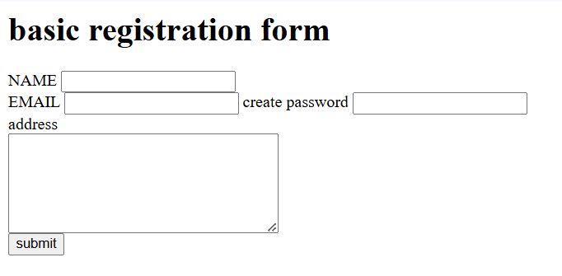

**Q19-**Write html cod to design a student admission form in html.

**ANS=**

<HTML>

<HEAD>

<title>form</title>

</head>

<body>

<h1>ADMISSION FORM</H1>

<FORM ACTION="https://www.codewithharry.com">

<fieldset>

<legend><font><b>UNIVERSITY REGISTRATION FORM</b></font></legend>

<B>First Name:</B>

<input type="text"/>

<B>Last Name:</B>

<input type="text"/><br>

<B>Father's Name:</B>

<input type="text"/>

<B>Mother's Name:</B>

<input type="text"/><br>

<B>Email:</B>

<input type="email"/><br>

<b>Phone.No-</b>

<input type="NUMBER" max length="10"/><BR><BR>

<b>10th MARKSHEET-</B>

<INPUT TYPE="FILE">

<B>12TH MARKSHEET-</B>

<INPUT TYPE="FILE"><BR>

<B> MIGRATION</B>

<INPUT TYPE="FILE">

<B> CHARACTER</B>

<INPUT TYPE="FILE"><BR><BR>

<B>GENDER</B><BR>

<INPUT TYPE="RADIO" NAME="GENDER">MALE<BR>

<INPUT TYPE="RADIO" NAME="GENDER">FEMALE<BR>

<INPUT TYPE="RADIO" NAME="GENDER">OTHER<BR>

<B><FONT SIZE="4">BACHELOR'S COURSE-</FONT></B><BR>

<INPUT TYPE="RADIO" NAME="COURSE">B.TECH<BR>

<INPUT TYPE="RADIO" NAME="COURSE">BSC<BR>

<INPUT TYPE="RADIO" NAME="COURSE">BBA<BR>

<INPUT TYPE="RADIO" NAME="COURSE">BCA<BR>

<INPUT TYPE="RADIO" NAME="COURSE">BSC/IT<BR><BR>

<B>EXTRA ACTIVITIES</B><BR>

<INPUT TYPE="CHECKBOX" NAME="ACTIVITIES">SPORTS<BR>

<INPUT TYPE="CHECKBOX" NAME="ACTIVITIES">DANCE<BR>

<INPUT TYPE="CHECKBOX" NAME="ACTIVITIES">GAMING<BR>

<INPUT TYPE="CHECKBOX" NAME="ACTIVITIES">CODING<BR>

<INPUT TYPE="CHECKBOX" NAME="ACTIVITIES">ACTING<BR>

<INPUT TYPE="CHECKBOX" NAME="ACTIVITIES">MUSIC<BR>

<INPUT LIST="SECTION" NAME="SECTION">

<DATALIST ID="SECTION">

<OPTION VALUE="1A">

<OPTION VALUE="2B">

<OPTION VALUE="23S">

<OPTION VALUE="44D">

</DATALIST>

<select id="section" name="section">

<option value="A">A</option>

<option value="B">B</option>

<option value="C">C</option>

<option value="D">D</option>

</select>

<B>DOB:</B>

<INPUT TYPE="DATE" MAX="2008" MIN="2003"/><BR><BR>

<B><FONT SIZE="5">INTRODUCTION</FONT></B><BR>

<TEXTAREA ROWS="10" COLS="50"></TEXTAREA><BR><BR>

<BUTTON type>SUBMIT</BUTTON>

<BUTTON>RESET</BUTTON>

</FIELDSET>

</form>

</body>

</html>

